Final Project Report

Nghia Lam - 1001699317; Gustavo Chavez - 1001789155; Patrick Arzoumanian - 1001855718

### Pictures

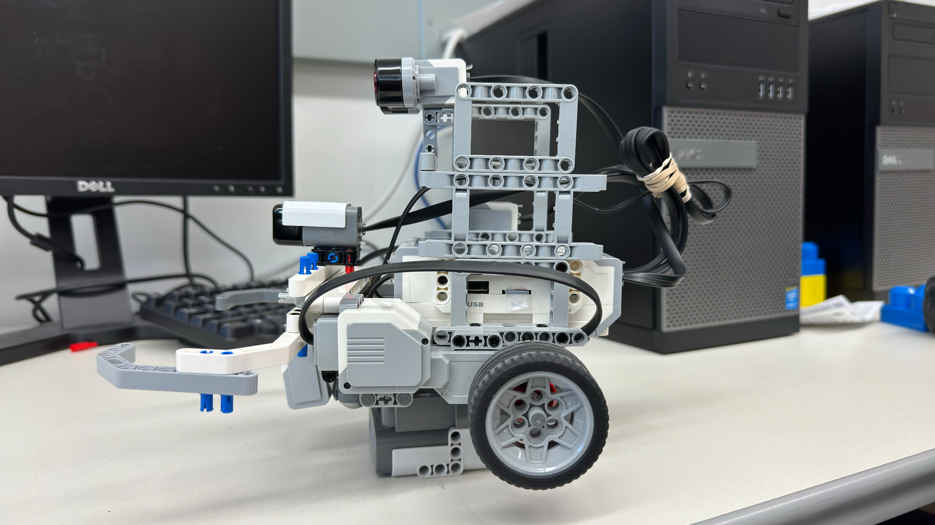

### Robot Description and Design

For this project, the goal was to create a robot that can play soccer most effectively. With this in mind, there are two end fields with colored tape representing the start of each end. In this case, the colors are red and blue. On top of this, there are walls in the game that help prevent the robot from wandering away from the field. Lastly, the ball that we will use is an IR ball that sends IR signals from the ball. With these factors in mind, we utilized two motors, to drive the robot, an IR sensor, to detect the ball, an ultrasonic sensor, to detect walls, a color sensor to detect if we have passed an opponent's end field, and a gyro sensor, to keep track of the current direction we are facing. We decided to mount the ultrasonic higher than the rest of the sensors since the main purpose of it will be to detect if we run into a wall. The gyro sensor’s placement wasn’t a concern in this project so we decided to place it off to the right. For the color sensor, we needed to ensure it was as close to the ground as possible to get accurate readings, so we mounted it in front of the ball allowing our robot to be nonholonomic. For the IR sensor, placement was very important as the sensor was not able to get accurate readings if it was placed too high or too low. After much experimenting the optimal placement of the sensor was just above the hands of the robot to sense if the ball was in its possession and to detect it out on the field.

### Navigation Strategy

Our navigation strategy, reminiscent of exploratory wandering, revolves around three core elements: random wandering, zone boundary adherence, and combined ball and wall detection.

The wandering component entails random directional shifts, either left or right, at intervals ranging from 0.2 to 0.4 seconds. This mechanism is designed to actively seek and detect the ball. Upon successful ball detection, the robot swiftly advances toward it to push it across the goal line.

Zone boundary detection is crucial for maintaining the robot's position within the designated area, demarcated by blue and red lines. This ensures the robot consistently operates within the specified limits throughout its operational cycle.

Finally, the integration of wall and ball detection systems enhances the robot's performance. As previously mentioned, the robot aggressively pursues the ball upon detection to score a goal. Simultaneously, wall detection prevents the robot from becoming trapped during its wandering phase. Encountering a wall triggers a reverse maneuver, followed by a turn to the left or right, in line with its current wandering direction. This dual detection system ensures smooth, uninterrupted navigation and efficient goal-scoring attempts.

### Problems Encountered

We ran into several problems when designing this robot. As mentioned before the IR sensor placement was very important so that we could get accurate readings. A lot of time and effort was spent on understanding how to get reliable readings. Also, we had trouble, initially, getting readings from the sensor so a small workaround was implemented. This workaround reads in the raw data from the sensor, goes byte per byte, and extracts the direction and strength of the signal received from each sensor.

Another issue we found is that as the ball rolls around the strength of the signal received at the sensor changes dramatically. This proved to be an issue when traveling with the ball to the opponent’s goal as sometimes the strength of the signal would drop and the robot would think it had lost the ball. Thus, causing the robot to lose momentum when heading towards the goal.

When it came to the gyro sensor sometimes the readings of the gyro sensor would climb significantly with no reason. We still don’t know why exactly it does this, but the fix to this issue was to completely restart the robot. For us to determine if this happens we need to test the robot before to ensure the gyro sensor is working as it should.